## Introduction

Our project is university portal system for university students and faculties. This system will keep important information and records of students and faculties saved and they can be checked anytime. They have to be registered first and after that they can logged into the account. Users can search for any task in the search bar. The system will be user friendly and user will find it very simple to use. Besides, it will ensure strong privacy of user personal information and records.

## Background And Product Context

University portal is an inevitable tool for the universities throughout the world. Hence the demand for university portal to develop is very high. Our portal has sign up and log in system for both faculties and students. There will be grades of each student that can be accessed only by the faculties. Students and faculties personal information will be stored and displayed here. Students can also see the taken courses when they want. This can be accessed only by the students. Besides, there will be many services to make life easier such as semester drop etc. Besides, there will be attendances of students and curriculum of departments.

## User Story & Use Case

1. **Title:** Home

**Actor**: Admin, Faculty, Instructor, Student

**Description**: It will have the following attributes:

* Name (Faculty, Instructor, Student)
* ID (Student)
* Email (Faculty, Instructor, Student)
* Degree (Student)
* Curriculum Name (Student)
* Faculty advisor (Student)
* Faculty Name (Student)
* Faculty Email (Student)

**Precondition:** None.

**Exception:** None.

1. **Title:** Profile Information

**Actor:** Faculty, Instructor, Student

**Description:** Students will able to see their information

**User Story:** As a student, I can check student information, as per my need.

**Precondition:** None.

**Exception:** None.

1. **Title:** Change Password

**Actor:** Admin, Faculty, Instructor, Student

**Description:** Admin, Student, Faculty, Instructor will able to change their own password. But admin will able to change everyone’s password.

**User Story:** As Admin/Student/Faculty/Instructor , I can change my password so that I can work on my account if I forget the password.

**Precondition:** Enter current password.

**Exception:** The following are the exceptions:

* Entered wrong current password.
* New password must match criteria.
* Confirm password doesn’t match.

1. **Title:** Grade History

**Actor:** Student

**Description:** Check grade history of all the completed courses.

**User Story:** As a student, I can check my previous semester grades so that I will be able to know my condition.

**Precondition:** None.

**Exception:** None.

1. **Title:** Payment Status

**Actor:** Student

**Description:** Check current balance.

**User Story:** As a student, I want to check current balance if it is needed.

**Precondition:** None.

**Exception:** None.

1. **Title:** Payment History

**Actor:** Student

**Description:** Check past payments.

**User Story:** As a student, I want to check past payments as per my need.

**Precondition:** None.

**Exception:** None.

1. **Title:** Attendance

**Actor:** Student

**Description:** View attendance.

**User Story:** As a student, I want to view attendance so that I can know about attendances of each courses of any semesters.

**Precondition:** None.

**Exception:** None.

1. **Title:** Faculty Evaluation

**Actor:** Student

**Description:** Evaluate faculty.

**User Story:** As a student, I can do faculty evaluation so that I will be eligible for advising.

**Precondition:** None.

**Exception:** All points must be checked.

1. **Title:** Curriculum

**Actor:** Student

**Description:** View enrolled curriculum.

**User Story:** As a student, I can see curriculum so that I can take courses mentioned in the curriculum.

**Precondition:** None.

**Exception:** None.

1. **Title:** Message History

**Actor:** Student

**Description:** Check message inbox.

**User Story:** As a student, I can check message so that I can learn about new notice from chairman, VC and IT.

**Precondition:** None.

**Exception:** None.

1. **Title:** User Guides

**Actor:** Admin, Faculty, Instructor, Student

**Description:** View the following guidelines:

* Recovery Password
* Access Portal
* Join Online Class
* Email Password Reset
* Message History
* Login to Classroom Using Mobile
* Email Through Mobile
* Add NID & Birth Certificate
* Advising
* Degree guideline

**User Story:** As a student/faculty/admin/instructor, I need a special option so that I can do the mentioned tasks as per my need.

**Precondition:** None.

**Exception:** None.

1. **Title:** Take Attendance

**Actor:** Faculty, Instructor

**Description:** Take students’ attendance.

**User Story:** As a faculty/instructor, I can take attendance so that I can do a regular activity of academic without doing manually.

**Precondition:** None.

**Exception:** Fill all the students’ attendance.

1. **Title:** Send Message

**Actor:** Faculty

**Description:** Send message to students.

**User Story:** As a faculty, I can send message to students so that I can inform students about class cancellation.

**Precondition:** None.

**Exception:** None.

1. **Title:** Grade Submission

**Actor:** Faculty

**Description:** Submit students’ grade.

**User Story:** As a faculty, I can submit students’ grades because of university authorities rule.

**Precondition:** None.

**Exception:** Must select from the predefined grade letter list.

1. **Title:** View Faculty Evaluation

**Actor:** Admin

**Description:** View faculty evaluation done by students.

**User Story:** As an admin, I can view faculty evaluation to judge faculties.

**Precondition:** None.

**Exception:** None.

1. **Title:** View Student Payment History

**Actor:** Admin

**Description:** View students’ payment history.

**User Story:** As an admin, I can view student payment history to check whom give the payments and whom are not.

**Precondition:** None.

**Exception:** None.

1. **Title:** Add Student

**Actor:** Admin

**Description:** Add student to database.

**User Story:** As an admin, I can add student who are new admitted or new advised.

**Precondition:** None.

**Exception:** The followings are exception:

* All the information must be given.
* Cannot have duplicates.

1. **Title:** Edit Student Information

**Actor:** Admin

**Description:** Edit student information.

**User Story:** As an admin, I can edit student information as per student’s need.

**Precondition:** Student must be in the database.

**Exception:** Cannot delete any information.

1. **Title:** Add Faculty

**Actor:** Admin

**Description:** Add faculty to database.

**User Story:** As an admin, I can add faculty whom are newly joined in the university.

**Precondition:** None.

**Exception:** The followings are exception:

* All the information must be given.
* Cannot have duplicates.

1. **Title:** Edit Faculty

**Actor:** Admin

**Description:** Edit faculty information.

**User Story:** As an admin , I can edit faculty information if it is needed by faculties.

**Precondition:** Faculty must be in the database.

**Exception:** Cannot delete any information.

1. **Title:** Add Instructor

**Actor:** Admin

**Description:** Add instructor to database.

**User Story:** As an admin, I can add instructor whom are newly joined in the institution.

**Precondition:** None.

**Exception:** The followings are exception:

* All the information must be given.
* Cannot have duplicates.

1. **Title:** Edit Instructor

**Actor:** Admin

**Description:** Edit instructor information.

**User Story:** As an admin, I can edit student information if it is needed.

**Precondition:** Instructor must be in the database.

**Exception:** Cannot delete any information.

1. **Title:** Advising

**Actor:** Admin, Faculty

**Description:** Enroll student to course section.

**User Story:** As an admin, I can advise to enroll student in each semester whom has done faculty evaluation.

**Precondition:** None.

**Exception:** The followings are exception:

* All the information must be given.
* Cannot have duplicates.
* Section cannot be full.

1. **Title:** Faculty Assign

**Actor:** Admin

**Description:** Assign faculty to course section.

**User Story:** As an admin, I can assign faculty members to each section so that all sections can get their faculty.

**Precondition:** None.

**Exception:** The followings are exception:

* All the information must be given.
* Cannot have duplicates.
* Only one faculty per section.

1. **Title:** Instructor Assign

**Actor:** Admin

**Description:** Assign instructor to course section.

**User Story:** As an admin, I can assign instructor to each section so that all section can get their instructors.

**Precondition:** None.

**Exception:** The followings are exception:

* All the information must be given.
* Cannot have duplicates.
* Only one instructor per section.

## Solution Description

* Front-end plan
* Main page
* Login or register a student or a teacher
* Student information/teacher information
* Student grade (only for student login)
* Taken courses (only for student login)
* Course curriculum (only for student login)
* Attendance
* Services
* Front-end mechanisms
* Bootstrap(js)
* Ajax(js)
* Back-end development

1. Account Creating, Password Recover

* Register form, and verification email.
* Login
* Forgot Password
* MySQL Database

1. Profile Management:

* Plan design and dev: MongoDB
* Student Profile
* Teacher Profile
* Others

1. Searching facility:

* Category based
* Back-end mechanisms
* PHP
* HTML
* MYSQL
* Editors
* VSCode
* Atom
* WebStorm
* Eclipse
* PhpStorm
* MySQL Workbench

## Development Plan

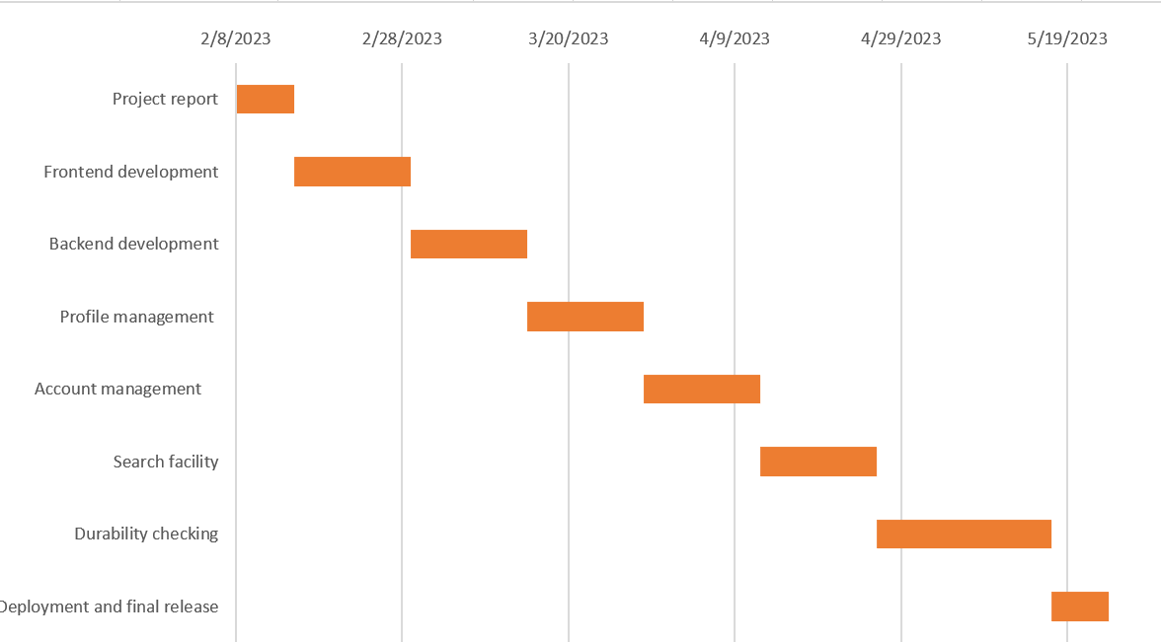

*Figure 1: Gantt chart of development plan*

## Collaboration Plan

| **Development** | **Member** |
| --- | --- |
| Front end and back-end development | Sadman Sakib Khan Promit |
| Profile management (Database) | Sadman Sakib Khan Promit |
| Account management | Sadman Sakib Khan Promit |
| Durability checking | Sadman Sakib Khan Promit |